ONEWAY response BY factor
/STATISTICS HOMOGENEITY
/MISSING ANALYSIS
/POSTHOC=TUKEY DUNCAN LSD DUNNETT ALPHA(0.05).

Oneway

Notes
Output Created |  | 11-JUN-2021 16:57:13
Comments
Input | Active Dataset | DataSet0
Input | Filter | <none>
Input | Weight | <none>
Input | Split File | <none>
Input | N of Rows in Working Data File | 25
Missing Value Handling | Definition of Missing | User-defined missing values are treated as missing.
Missing Value Handling | Cases Used | Statistics for each analysis are based on cases with no missing data for any variable in the analysis.
Syntax |  | ONEWAY response BY factor  /STATISTICS HOMOGENEITY  /MISSING ANALYSIS  /POSTHOC=TUKEY DUNCAN LSD DUNNETT ALPHA(0.05).
Resources | Processor Time | 00:00:00.22
Resources | Elapsed Time | 00:00:00.39

[DataSet0]

Test of Homogeneity of Variances
 |  | Levene Statistic | df1 | df2 | Sig.
response | Based on Mean | .644 | 4 | 20 | .637
response | Based on Median | .318 | 4 | 20 | .863
response | Based on Median and with adjusted df | .318 | 4 | 17.767 | .862
response | Based on trimmed mean | .656 | 4 | 20 | .630

ANOVA
response
 | Sum of Squares | df | Mean Square | F | Sig.
Between Groups | 475.760 | 4 | 118.940 | 14.757 | .000
Within Groups | 161.200 | 20 | 8.060
Total | 636.960 | 24

Post Hoc Tests

Multiple Comparisons
Dependent Variable: response
 | (I) factor | (J) factor | Mean Difference (I-J) | Std. Error | Sig. | 95% Confidence Interval
 |  |  |  |  |  | Lower Bound | Upper Bound
Tukey HSD | .00 | 4.00 | -5.60000* | 1.79555 | .039 | -10.9730 | -.2270
Tukey HSD | .00 | 6.00 | -7.80000* | 1.79555 | .003 | -13.1730 | -2.4270
Tukey HSD | .00 | 8.00 | -11.80000* | 1.79555 | .000 | -17.1730 | -6.4270
Tukey HSD | .00 | 10.00 | -1.00000 | 1.79555 | .980 | -6.3730 | 4.3730
Tukey HSD | 4.00 | .00 | 5.60000* | 1.79555 | .039 | .2270 | 10.9730
Tukey HSD | 4.00 | 6.00 | -2.20000 | 1.79555 | .737 | -7.5730 | 3.1730
Tukey HSD | 4.00 | 8.00 | -6.20000* | 1.79555 | .019 | -11.5730 | -.8270
Tukey HSD | 4.00 | 10.00 | 4.60000 | 1.79555 | .116 | -.7730 | 9.9730
Tukey HSD | 6.00 | .00 | 7.80000* | 1.79555 | .003 | 2.4270 | 13.1730
Tukey HSD | 6.00 | 4.00 | 2.20000 | 1.79555 | .737 | -3.1730 | 7.5730
Tukey HSD | 6.00 | 8.00 | -4.00000 | 1.79555 | .210 | -9.3730 | 1.3730
Tukey HSD | 6.00 | 10.00 | 6.80000* | 1.79555 | .009 | 1.4270 | 12.1730
Tukey HSD | 8.00 | .00 | 11.80000* | 1.79555 | .000 | 6.4270 | 17.1730
Tukey HSD | 8.00 | 4.00 | 6.20000* | 1.79555 | .019 | .8270 | 11.5730
Tukey HSD | 8.00 | 6.00 | 4.00000 | 1.79555 | .210 | -1.3730 | 9.3730
Tukey HSD | 8.00 | 10.00 | 10.80000* | 1.79555 | .000 | 5.4270 | 16.1730
Tukey HSD | 10.00 | .00 | 1.00000 | 1.79555 | .980 | -4.3730 | 6.3730
Tukey HSD | 10.00 | 4.00 | -4.60000 | 1.79555 | .116 | -9.9730 | .7730
Tukey HSD | 10.00 | 6.00 | -6.80000* | 1.79555 | .009 | -12.1730 | -1.4270
Tukey HSD | 10.00 | 8.00 | -10.80000* | 1.79555 | .000 | -16.1730 | -5.4270
LSD | .00 | 4.00 | -5.60000* | 1.79555 | .005 | -9.3455 | -1.8545
LSD | .00 | 6.00 | -7.80000* | 1.79555 | .000 | -11.5455 | -4.0545
LSD | .00 | 8.00 | -11.80000* | 1.79555 | .000 | -15.5455 | -8.0545
LSD | .00 | 10.00 | -1.00000 | 1.79555 | .584 | -4.7455 | 2.7455
LSD | 4.00 | .00 | 5.60000* | 1.79555 | .005 | 1.8545 | 9.3455
LSD | 4.00 | 6.00 | -2.20000 | 1.79555 | .235 | -5.9455 | 1.5455
LSD | 4.00 | 8.00 | -6.20000* | 1.79555 | .003 | -9.9455 | -2.4545
LSD | 4.00 | 10.00 | 4.60000* | 1.79555 | .019 | .8545 | 8.3455
LSD | 6.00 | .00 | 7.80000* | 1.79555 | .000 | 4.0545 | 11.5455
LSD | 6.00 | 4.00 | 2.20000 | 1.79555 | .235 | -1.5455 | 5.9455
LSD | 6.00 | 8.00 | -4.00000* | 1.79555 | .038 | -7.7455 | -.2545
LSD | 6.00 | 10.00 | 6.80000* | 1.79555 | .001 | 3.0545 | 10.5455
LSD | 8.00 | .00 | 11.80000* | 1.79555 | .000 | 8.0545 | 15.5455
LSD | 8.00 | 4.00 | 6.20000* | 1.79555 | .003 | 2.4545 | 9.9455
LSD | 8.00 | 6.00 | 4.00000* | 1.79555 | .038 | .2545 | 7.7455
LSD | 8.00 | 10.00 | 10.80000* | 1.79555 | .000 | 7.0545 | 14.5455
LSD | 10.00 | .00 | 1.00000 | 1.79555 | .584 | -2.7455 | 4.7455
LSD | 10.00 | 4.00 | -4.60000* | 1.79555 | .019 | -8.3455 | -.8545
LSD | 10.00 | 6.00 | -6.80000* | 1.79555 | .001 | -10.5455 | -3.0545
LSD | 10.00 | 8.00 | -10.80000* | 1.79555 | .000 | -14.5455 | -7.0545
Dunnett t (2-sided)^{b} | .00 | 10.00 | -1.00000 | 1.79555 | .947 | -5.7601 | 3.7601
Dunnett t (2-sided)^{b} | 4.00 | 10.00 | 4.60000 | 1.79555 | .060 | -.1601 | 9.3601
Dunnett t (2-sided)^{b} | 6.00 | 10.00 | 6.80000* | 1.79555 | .004 | 2.0399 | 11.5601
Dunnett t (2-sided)^{b} | 8.00 | 10.00 | 10.80000* | 1.79555 | .000 | 6.0399 | 15.5601

*. The mean difference is significant at the 0.05 level.
b. Dunnett t-tests treat one group as a control, and compare all other groups against it.

Homogeneous Subsets

response
 | factor | N | Subset for alpha = 0.05
 | factor | N | 1 | 2 | 3 | 4
Tukey HSDª | .00 | 5 | 9.8000
Tukey HSDª | 10.00 | 5 | 10.8000 | 10.8000
Tukey HSDª | 4.00 | 5 |  | 15.4000 | 15.4000
Tukey HSDª | 6.00 | 5 |  |  | 17.6000 | 17.6000
Tukey HSDª | 8.00 | 5 |  |  |  | 21.6000
Tukey HSDª | Sig. |  | .980 | .116 | .737 | .210
Duncanª | .00 | 5 | 9.8000
Duncanª | 10.00 | 5 | 10.8000
Duncanª | 4.00 | 5 |  | 15.4000
Duncanª | 6.00 | 5 |  | 17.6000
Duncanª | 8.00 | 5 |  |  | 21.6000
Duncanª | Sig. |  | .584 | .235 | 1.000

Means for groups in homogeneous subsets are displayed.
a. Uses Harmonic Mean Sample Size = 5.000.

NPAR TESTS
/K-W=response BY factor(0 10)
/STATISTICS DESCRIPTIVES
/MISSING ANALYSIS.

NPar Tests

Notes
Output Created |  | 11-JUN-2021 17:06:33
Comments
Input | Active Dataset | DataSet0
Input | Filter | <none>
Input | Weight | <none>
Input | Split File | <none>
Input | N of Rows in Working Data File | 25
Missing Value Handling | Definition of Missing | User-defined missing values are treated as missing.
Missing Value Handling | Cases Used | Statistics for each test are based on all cases with valid data for the variable(s) used in that test.
Syntax |  | NPAR TESTS  /K-W=response BY factor(0 10)  /STATISTICS DESCRIPTIVES  /MISSING ANALYSIS.
Resources | Processor Time | 00:00:00.00
Resources | Elapsed Time | 00:00:00.00
Resources | Number of Cases Allowedª | 449389

a. Based on availability of workspace memory.

Descriptive Statistics
 | N | Mean | Std. Deviation | Minimum | Maximum
response | 25 | 15.0400 | 5.15170 | 7.00 | 25.00
factor | 25 | 5.6000 | 3.51188 | .00 | 10.00

Kruskal-Wallis Test

Ranks
 | factor | N | Mean Rank
response | .00 | 5 | 5.50
response | 4.00 | 5 | 13.20
response | 6.00 | 5 | 17.00
response | 8.00 | 5 | 22.60
response | 10.00 | 5 | 6.70
response | Total | 25

Test Statistics^{a,b}
 | response
Kruskal-Wallis H | 19.064
df | 4
Asymp. Sig. | .001

a. Kruskal Wallis Test
b. Grouping Variable: factor

UNIANOVA response BY factor
/METHOD=SSTYPE(3)
/INTERCEPT=INCLUDE
/SAVE=PRED RESID ZRESID SRESID
/CRITERIA=ALPHA(0.05)
/DESIGN=factor.

Univariate Analysis of Variance

Notes
Output Created |  | 11-JUN-2021 17:11:50
Comments
Input | Active Dataset | DataSet0
Input | Filter | <none>
Input | Weight | <none>
Input | Split File | <none>
Input | N of Rows in Working Data File | 25
Missing Value Handling | Definition of Missing | User-defined missing values are treated as missing.
Missing Value Handling | Cases Used | Statistics are based on all cases with valid data for all variables in the model.
Syntax |  | UNIANOVA response BY factor  /METHOD=SSTYPE(3)  /INTERCEPT=INCLUDE  /SAVE=PRED RESID ZRESID SRESID  /CRITERIA=ALPHA(0.05)  /DESIGN=factor.
Resources | Processor Time | 00:00:00.02
Resources | Elapsed Time | 00:00:00.02
Variables Created or Modified | PRE_1 | Predicted Value for response
Variables Created or Modified | RES_1 | Residual for response
Variables Created or Modified | ZRE_1 | Standardized Residual for response
Variables Created or Modified | SRE_1 | Studentized Residual for response

Between-Subjects Factors
 |  | N
factor | .00 | 5
factor | 4.00 | 5
factor | 6.00 | 5
factor | 8.00 | 5
factor | 10.00 | 5

Tests of Between-Subjects Effects
Dependent Variable: response
Source | Type III Sum of Squares | df | Mean Square | F | Sig.
Corrected Model | 475.760ª | 4 | 118.940 | 14.757 | .000
Intercept | 5655.040 | 1 | 5655.040 | 701.618 | .000
factor | 475.760 | 4 | 118.940 | 14.757 | .000
Error | 161.200 | 20 | 8.060
Total | 6292.000 | 25
Corrected Total | 636.960 | 24

a. R Squared = .747 (Adjusted R Squared = .696)

GRAPH
/SCATTERPLOT(BIVAR)=PRE_1 WITH RES_1
/MISSING=LISTWISE.

Graph

Notes
Output Created |  | 11-JUN-2021 17:15:03
Comments
Input | Active Dataset | DataSet0
Input | Filter | <none>
Input | Weight | <none>
Input | Split File | <none>
Input | N of Rows in Working Data File | 25
Syntax |  | GRAPH  /SCATTERPLOT(BIVAR)=PRE_1 WITH RES_1  /MISSING=LISTWISE.
Resources | Processor Time | 00:00:00.22
Resources | Elapsed Time | 00:00:00.17

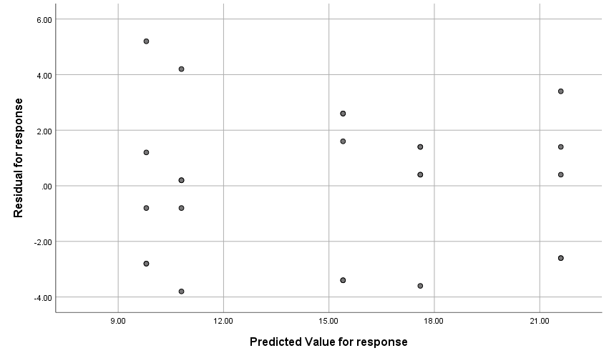

GRAPH
/SCATTERPLOT(BIVAR)=PRE_1 WITH ZRE_1
/MISSING=LISTWISE.

Graph

Notes
Output Created |  | 11-JUN-2021 17:17:12
Comments
Input | Active Dataset | DataSet0
Input | Filter | <none>
Input | Weight | <none>
Input | Split File | <none>
Input | N of Rows in Working Data File | 25
Syntax |  | GRAPH  /SCATTERPLOT(BIVAR)=PRE_1 WITH ZRE_1  /MISSING=LISTWISE.
Resources | Processor Time | 00:00:00.23
Resources | Elapsed Time | 00:00:00.17

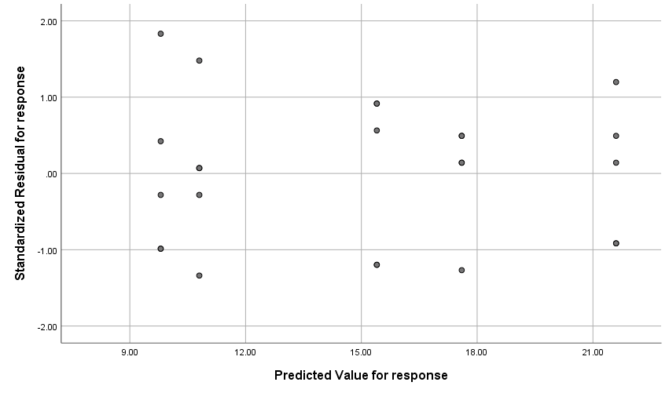

GRAPH
/SCATTERPLOT(BIVAR)=PRE_1 WITH SRE_1
/MISSING=LISTWISE.

Graph

Notes
Output Created |  | 11-JUN-2021 17:17:28
Comments
Input | Active Dataset | DataSet0
Input | Filter | <none>
Input | Weight | <none>
Input | Split File | <none>
Input | N of Rows in Working Data File | 25
Syntax |  | GRAPH  /SCATTERPLOT(BIVAR)=PRE_1 WITH SRE_1  /MISSING=LISTWISE.
Resources | Processor Time | 00:00:00.20
Resources | Elapsed Time | 00:00:00.17

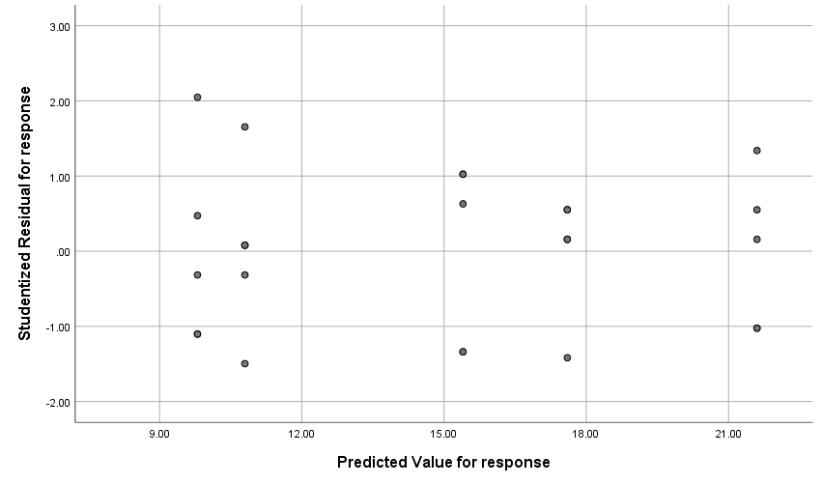

PPLOT
/VARIABLES=RES_1
/NOLOG
/NOSTANDARDIZE
/TYPE=P-P
/FRACTION=BLOM
/TIES=MEAN
/DIST=NORMAL.

PPlot

Notes
Output Created |  | 11-JUN-2021 17:18:35
Comments
Input | Active Dataset | DataSet0
Input | Filter | <none>
Input | Weight | <none>
Input | Split File | <none>
Input | N of Rows in Working Data File | 25
Input | Date | <none>
Missing Value Handling | Definition of Missing | User-defined missing values are treated as missing.
Missing Value Handling | Cases Used | For a given sequence or time series variable, cases with missing values are not used in the analysis. Cases with negative or zero values are also not used, if the log transform is requested.
Syntax |  | PPLOT  /VARIABLES=RES_1  /NOLOG  /NOSTANDARDIZE  /TYPE=P-P  /FRACTION=BLOM  /TIES=MEAN  /DIST=NORMAL.
Resources | Processor Time | 00:00:00.34
Resources | Elapsed Time | 00:00:00.27
Use | From | First observation
Use | To | Last observation
Time Series Settings (TSET) | Amount of Output | PRINT = DEFAULT
Time Series Settings (TSET) | Saving New Variables | NEWVAR = CURRENT
Time Series Settings (TSET) | Maximum Number of Lags in Autocorrelation or Partial Autocorrelation Plots | MXAUTO = 16
Time Series Settings (TSET) | Maximum Number of Lags Per Cross-Correlation Plots | MXCROSS = 7
Time Series Settings (TSET) | Maximum Number of New Variables Generated Per Procedure | MXNEWVAR = 60
Time Series Settings (TSET) | Maximum Number of New Cases Per Procedure | MXPREDICT = 1000
Time Series Settings (TSET) | Treatment of User-Missing Values | MISSING = EXCLUDE
Time Series Settings (TSET) | Confidence Interval Percentage Value | CIN = 95
Time Series Settings (TSET) | Tolerance for Entering Variables in Regression Equations | TOLER = .0001
Time Series Settings (TSET) | Maximum Iterative Parameter Change | CNVERGE = .001
Time Series Settings (TSET) | Method of Calculating Std. Errors for Autocorrelations | ACFSE = IND
Time Series Settings (TSET) | Length of Seasonal Period | Unspecified
Time Series Settings (TSET) | Variable Whose Values Label Observations in Plots | Unspecified
Time Series Settings (TSET) | Equations Include | CONSTANT

Model Description
Model Name |  | MOD_1
Series or Sequence | 1 | Residual for response
Transformation |  | None
Non-Seasonal Differencing |  | 0
Seasonal Differencing |  | 0
Length of Seasonal Period |  | No periodicity
Standardization |  | Not applied
Distribution | Type | Normal
Distribution | Location | estimated
Distribution | Scale | estimated
Fractional Rank Estimation Method |  | Blom's
Rank Assigned to Ties |  | Mean rank of tied values

Applying the model specifications from MOD_1

Case Processing Summary
 |  | Residual for response
Series or Sequence Length |  | 25
Number of Missing Values in the Plot | User-Missing | 0
Number of Missing Values in the Plot | System-Missing | 0

The cases are unweighted.

Estimated Distribution Parameters
 |  | Residual for response
Normal Distribution | Location |  | .0000
Normal Distribution | Scale |  | 2.59165

The cases are unweighted.

Residual for response

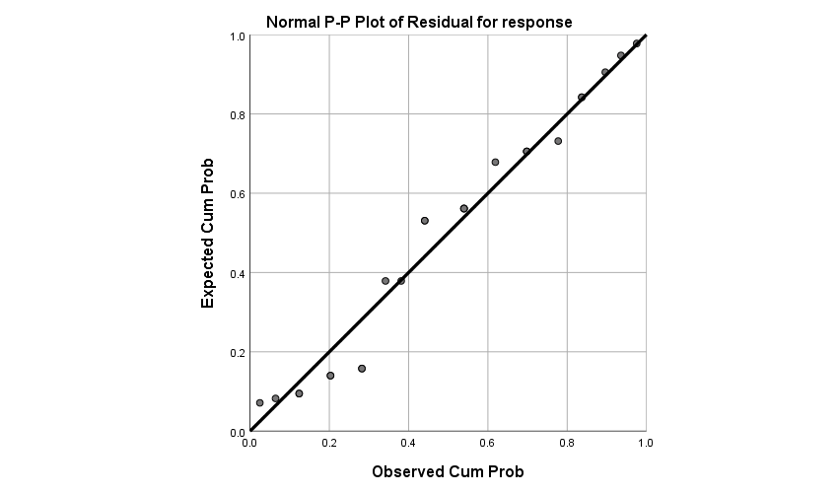

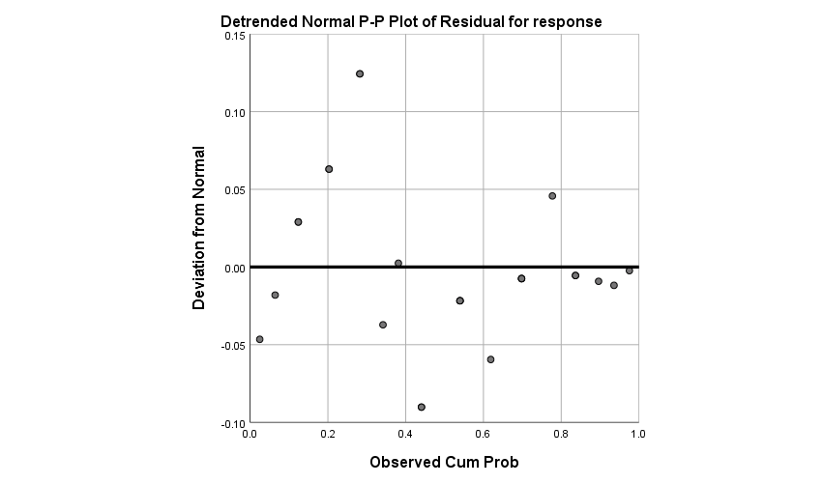

DATASET ACTIVATE DataSet0.
DATASET ACTIVATE DataSet‎‪0‬.

SAVE OUTFILE='F:\lessons\‏‫طرح‬ ‏‫آزمایش‬ ‏‫ها‬\codes\first.sav'
/COMPRESSED.
DATASET ACTIVATE DataSet‎‪0‬.

